Hypohektika (Germany) PRESENTS: Suddenly[PWR002]

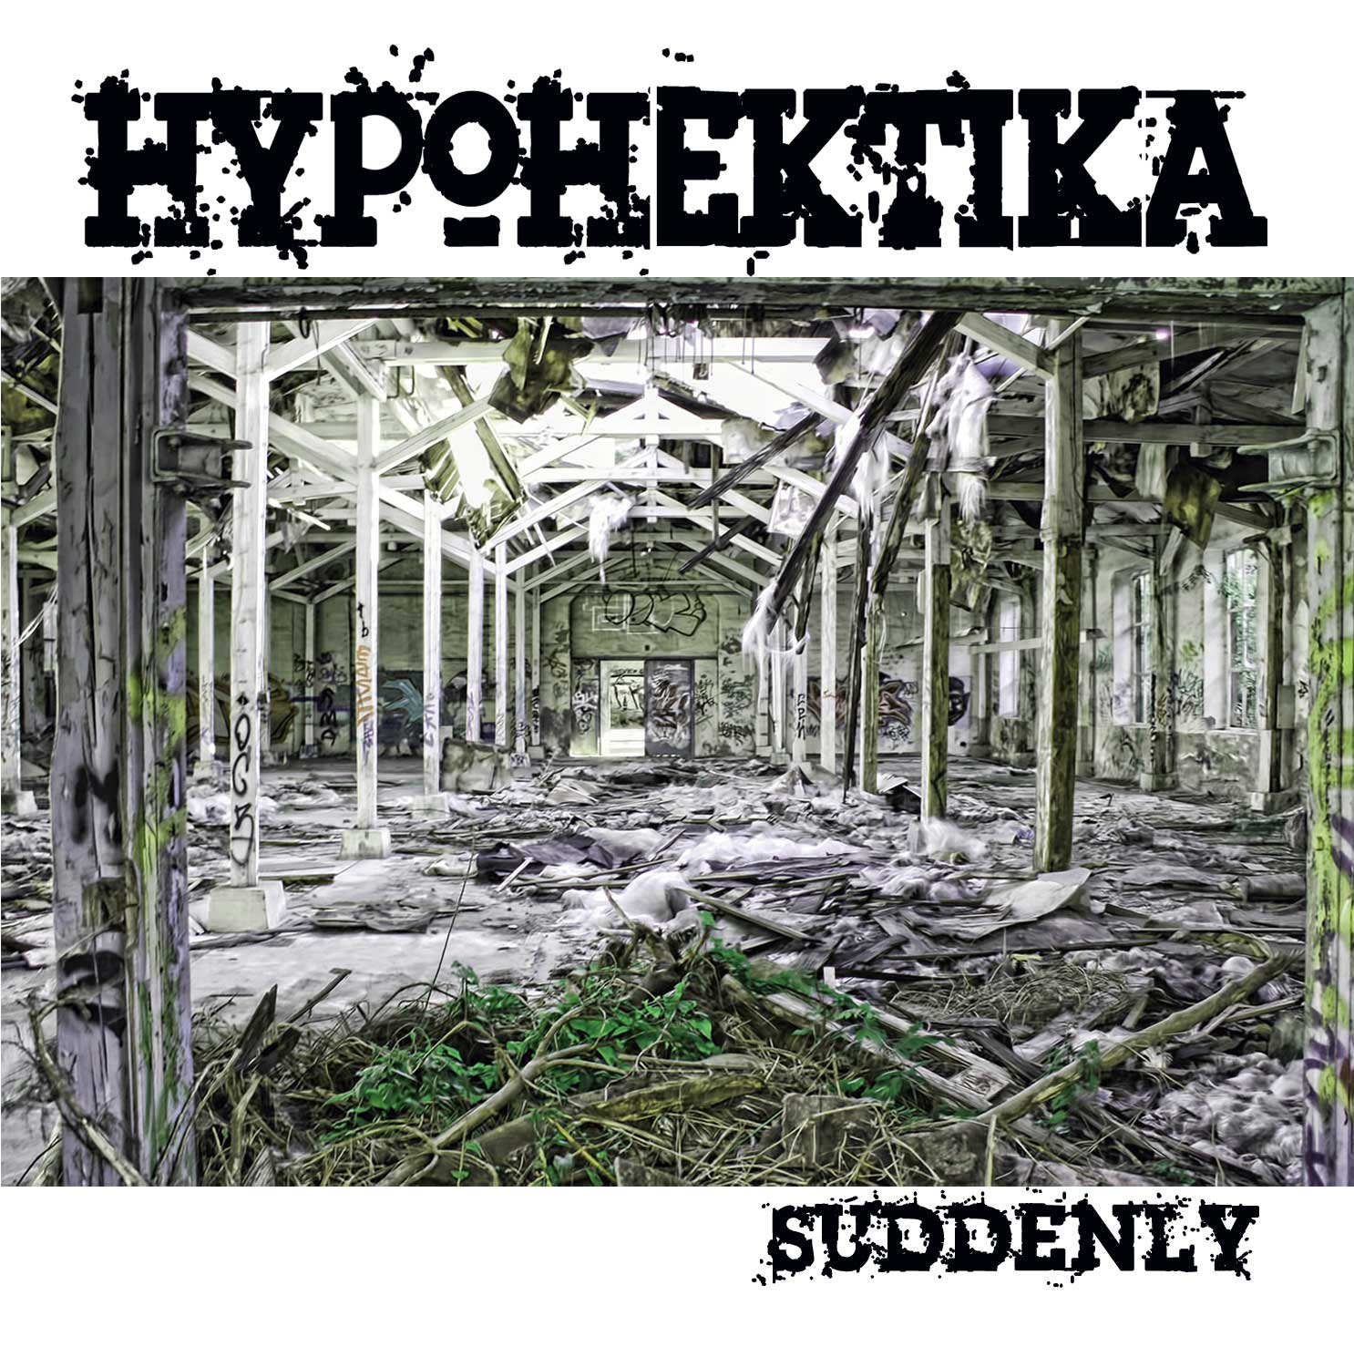 |  | RELEASE NOTES  Deep progressive Beats and Basslines, Dark Riffs and hooks, clicking percussion, and deep spheres. NEW RELEASE 2009  German Electronic music artist Hypohektika’s new release Suddenly. Is preceding his second release "The Devils Microwave EP" which comes along with 4 gloomy minimal progressive trance tracks.  One more time deep bass lines clash together with tripping sounds and broad atmospheres. To create an amazing sounds cape of poetically woven together beats and melodies to create a deep experience for all international listeners.  Artist Profile:  Thomas F. is a 26 years old new artist of the northern Germany Psytrance scene. He’s living near the city of Hamburg directly at the baltic sea. In the late nineties he produces techno sounds and came about detours to psychedelic trance. After some years of experimentation he find to his actually sound, between deep and dark progressive and digital technology morning trance. His trademark is the bent to experimental minimalistic sounds paired with a trace of hard squeezing bass drums.  After his second release "The Devils Microwave EP" which comes along with 4 gloomy minimal progressive trance tracks. One more time deep bass lines clash together with tripping sounds and broad atmospheres. The EP is the sixth release of the net label multiplex records.  Label Profile:  Power House Records Specializing in Hard Dance, NRG, and Acid Techno / Hard House “mash-ups”, expect to see innovative and cutting edge releases pumping out of this super blasting EDM label from Germany. Power House Records produces releases on Vinyl, Digital EPs, DJ mix CDs, and exclusive digital singles. PHR (Power House Records) has a world wide distribution network is most known for its white label releases that have sold like hot cakes every time they surface. The world is ready for house music with more power and a special European twist to give it new life. Power House Records is this new blood to PUMP IT UP! More info coming soon.
Title: | SUDDENLY
Artist: | HYPOHEKTIKA
Label: | Power House Records
Catalogue: | Pwrcd002
Format: | Jewel Case 4 panel CD
Barcode: | 881034378316
Release: | OCT 2009
TRACK LIST

01 Suddenly
02 Semitdoog
03 FX Schredd Tuned
04 Chicken Teriyaki
05 Tarentum
06 Exotic Tribb (2009 mix)
07 Killing Minds (2009 mix)
08 Easterwalk
10 1996

CREDITS
(p) and © Power House Records, Germany distribution and publishing by Geomagnetic.tv
www.geomagnetic.tv
info@geomagnetic.tv



